**Korean Beef Stew**

By [camille](https://www.allrecipes.com/cook/2256277/)

[[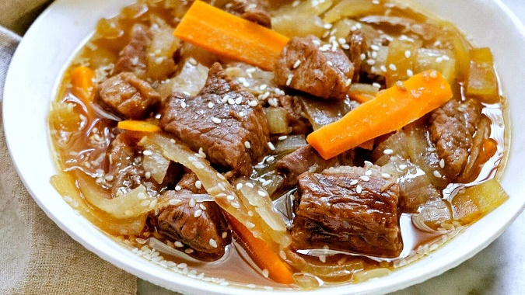](https://www.allrecipes.com/recipe/273203/korean-beef-stew/?utm_medium=browser&utm_source=allrecipes.com&utm_content=20210129&utm_campaign=793621)](https://www.allrecipes.com/recipe/273203/korean-beef-stew/?utm_medium=browser&utm_source=allrecipes.com&utm_content=20210129&utm_campaign=793621)

½ stick butter

2 onions, sliced

2 tablespoons minced garlic

2 ¼ pounds boneless stewing beef, cut into 1-inch (2.5 cm) pieces

6 cups water

¾ cup rice wine

½ cup soy sauce

½ cup brown sugar

⅓ cup honey

5 shiitake mushrooms, sliced

½ teaspoon chile-garlic sauce

1 carrot, sliced

¼ cup toasted sesame seeds

salt and ground black pepper to taste

2 tablespoons sesame oil

1. Melt butter in a large skillet over medium heat. Add onion and garlic; cook for 1 to 3 minutes. Add beef; cook and stir until brown, about 15 minutes.

2. Add water, rice wine, soy sauce, brown sugar, honey, mushrooms, and chile-garlic sauce to the skillet with the beef. Simmer until beef is tender, about 60 minutes more.

3. Add carrot and sesame seeds to the skillet with the stew. Season with salt and pepper. Continue cooking until 1/2 the liquid has evaporated, about 15 minutes. Drizzle in sesame oil and remove from heat.

https://www.allrecipes.com/recipe/273203/korean-beef-stew/?utm_medium=browser&utm_source=allrecipes.com&utm_content=20210129&utm_campaign=793621